**Kerberos Installation : SEBC:-CHALLENGE**

Step 1 : Install krb-server, krb5-libs and krb5-workstations

# yum install krb5-server krb5-libs krb5-workstation

Step 2 : KDC server configuration in the Kerberos configuration file 🡪 krb5.conf

# vi /etc/krb5.conf

Default REALM will be EXAMPLE.COM. Change the REALM and kdc-server and admin-server.

“ [realms]

EXAMPLE.COM = {

kdc = my.kdc.server

admin_server = my.kdc.server

}”

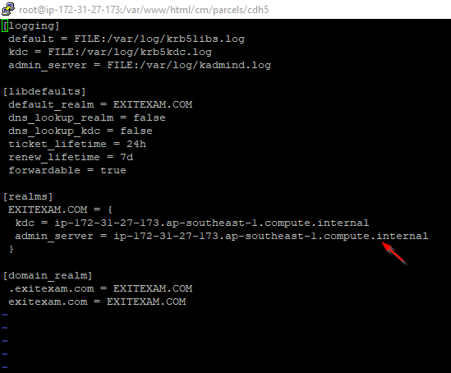

Step 3 : Create the Kerberos Database

Use the utility kdb5_util to create the Kerberos database.

# kdb5_util create -s

Step :

Start the KDC Server and KDC admin server

# service krb5kdc start

# service kadmin start

# chkconfig krb5kdc on

# chkconfig kadmin on

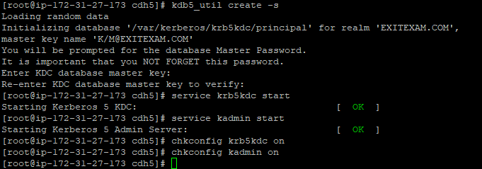

Step 4 :

Create a KDC admin by creating an admin principal.

# kadmin.local -q "addprinc admin/admin"

Confirm that this admin principal has permissions in the KDC ACL. Using a text editor, open the

KDC ACL file:

# vi /var/kerberos/krb5kdc/kadm5.acl

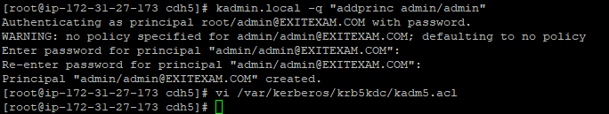

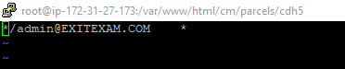

Step 5 : Restart the kadmin server : - # service kadmin restart

**Enabling Kerberos through Cloudera Manager**

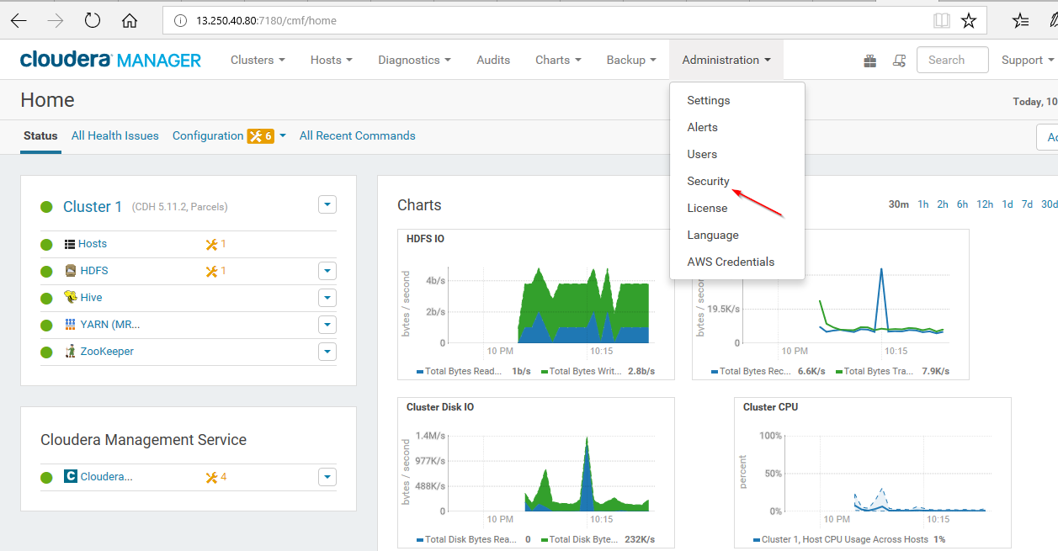

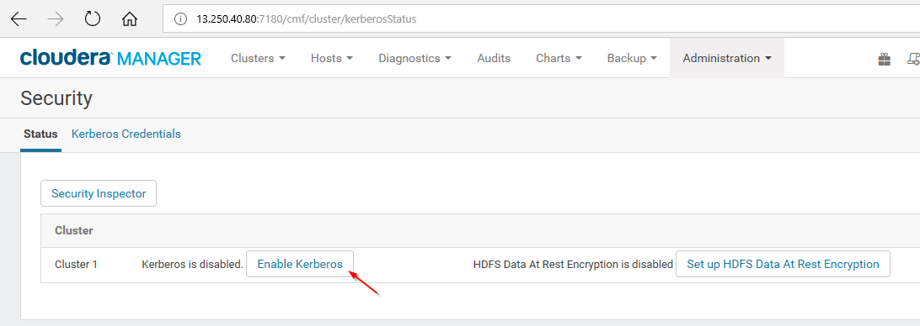

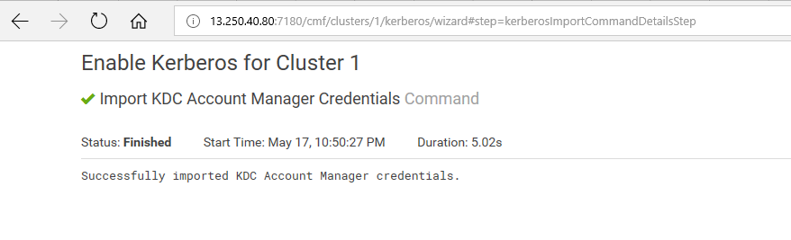

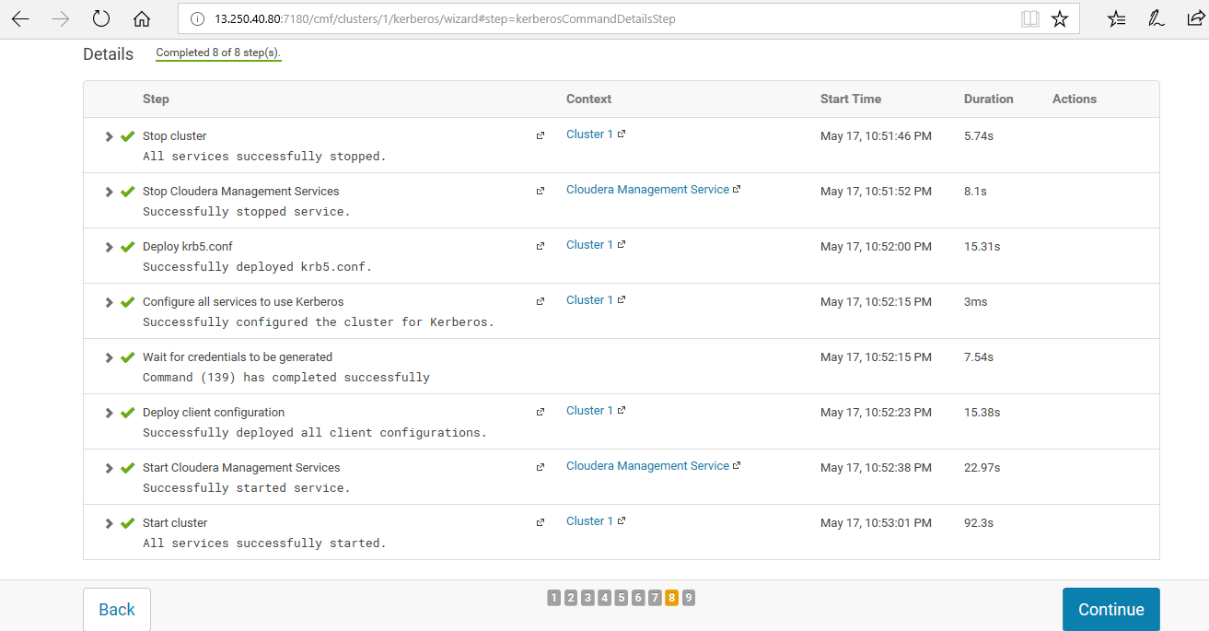

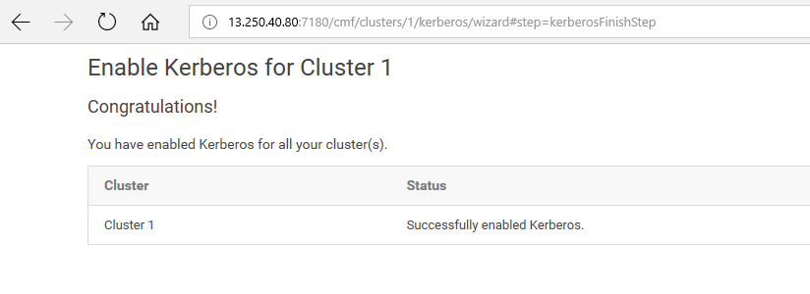

**-🡪** Successfully enabled KerberosSS